Fundamentals of Computing Documentation

Software Requirements Specification

Version 1.0

Date

Roy Cus
Dale Casimiro
Abner Mencia
Nolan Lockwood

Lead Software Engineer

Prepared for
FOC

Revision History

Date | Description | Author | Comments
November 29, 2020 | Version 1 | Roy Cus | First Revision

Document Approval

The following Software Requirements Specification has been accepted and approved by the following:
Signature | Printed Name | Title | Date
 | Roy Cus | Lead Software Eng. | November 29, 2020
 | Kieran Ryan | Instructor, CptS 322

Table of Contents

Revision History ii
Document Approval ii
1. Introduction 1
1.1 Purpose 1
1.2 Scope 1
1.3 Definitions, Acronyms, and Abbreviations 1
1.4 References 1
2. General Description 2
2.1 Product Perspective 2
2.2 Product Functions 2
2.3 User Characteristics 2
2.4 General Constraints 2
3. Specific Requirements 2
3.3 Use Cases 3
3.3.1 Use Case #1 3
3.5 Non-Functional Requirements 4
3.5.1 Performance 4
3.5.2 Reliability 4
3.5.3 Availability 4
3.5.4 Security 4
3.5.5 Maintainability 4
3.5.6 Portability 4
3.7 Design Constraints 4
3.8 Logical Database Requirements 4
3.9 Other Requirements 4
4. Analysis Models 4
4.1 Sequence Diagrams 5
4.3 Data Flow Diagrams (DFD) 5
5. Change Management Process 5
A. Appendices 5
A.1 Appendix 1 5
A.2 Appendix 2 5

1. Introduction
The introduction to the Software Requirement Specification (SRS) document should provide an overview of the complete SRS document. This document contain all of the information needed by a software engineer to adequately design and implement the software product described by the requirements listed in this document. (Note: the following subsection annotates are largely taken from the IEEE Guide to SRS).

1.1 Purpose
The intended audience for this projects are for the teachers…

1.3 Definitions, Acronyms, and Abbreviations

SQL short for Structured Query Language.

2. General Description
This section of the SRS should describe the general factors that affect 'the product and its requirements. It should be made clear that this section does not state specific requirements; it only makes those requirements easier to understand.

2.1 Product Perspective
This subsection of the SRS puts the product into perspective with other related products or
projects. (See the IEEE Guide to SRS for more details).

2.3 User Characteristics
This subsection of the SRS should describe those general characteristics of the eventual users of the product that will affect the specific requirements. (See the IEEE Guide to SRS for more details).

2.4 General Constraints
This subsection of the SRS should provide a general description of any other items that will
limit the developer’s options for designing the system. (See the IEEE Guide to SRS for a partial list of possible general constraints).

3.3 Use Cases

Use Case Diagram
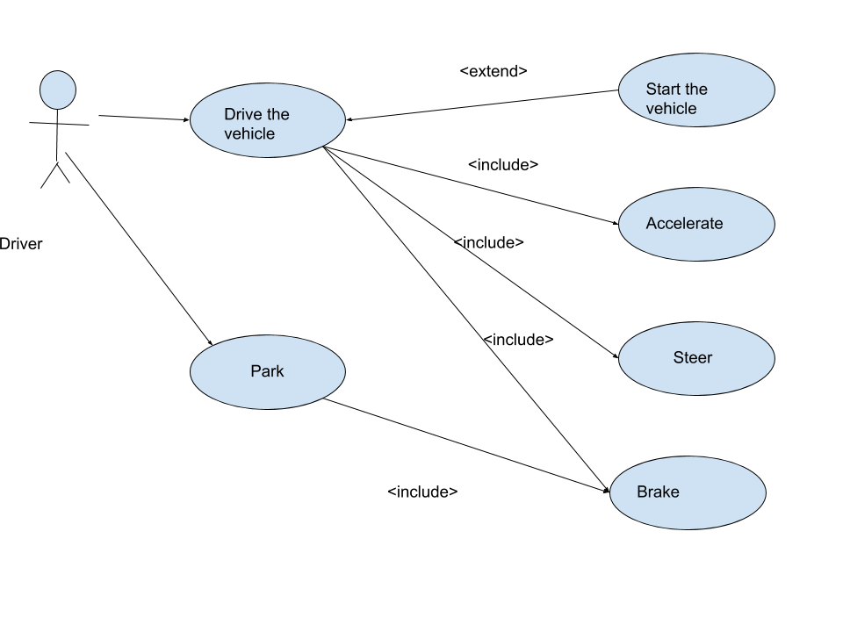

3.5 Non-Functional Requirements
Non-functional requirements may exist for the following attributes. Often these requirements must be achieved at a system-wide level rather than at a unit level. State the requirements in the following sections in measurable terms (e.g., 95% of transaction shall be processed in less than a second, system downtime may not exceed 1 minute per day, > 30 day MTBF value, etc).

3.7 Design Constraints
Specify design constrains imposed by other standards, company policies, hardware limitation, etc. that will impact this software project.

3.8 Logical Database Requirements
Will a database be used? If so, what logical requirements exist for data formats, storage capabilities, data retention, data integrity, etc.

4. Analysis Models
List all analysis models used in developing specific requirements previously given in this SRS. Each model should include an introduction and a narrative description. Furthermore, each model should be traceable the SRS’s requirements.

4.1 Sequence Diagrams
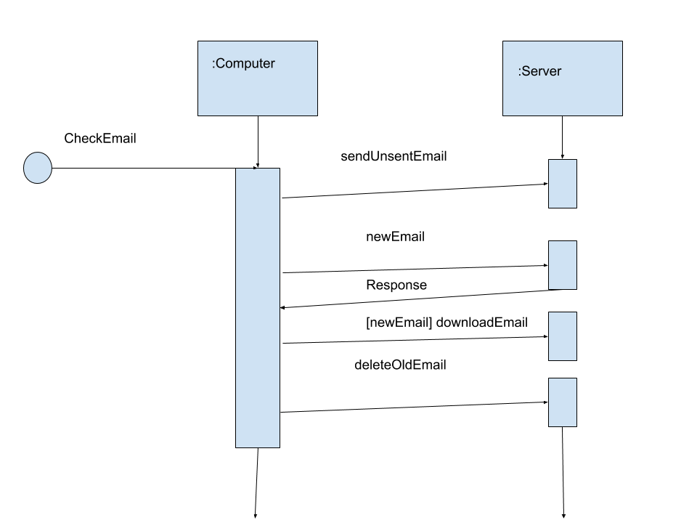

4.3 Data Flow Diagrams (DFD)
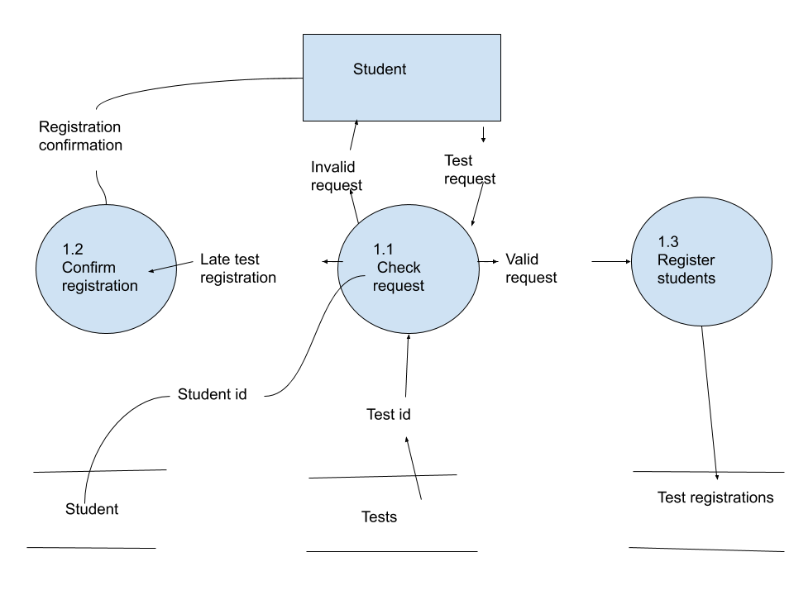

5. Change Management Process
Identify and describe the process that will be used to update the SRS, as needed, when project scope or requirements change. Who can submit changes and by what means, and how will these changes be approved.

A. Appendices
Appendices may be used to provide additional (and hopefully helpful) information. If present, the SRS should explicitly state whether the information contained within an appendix is to be considered as a part of the SRS’s overall set of requirements.

Example Appendices could include (initial) conceptual documents for the software project, marketing materials, minutes of meetings with the customer(s), etc.

